

**ePortal Student Alerts** Setup Guide

This guide will go through the steps needed to setup an alert for a student using ePortal. It will show you how to create the alert and where the alert will show up once it has been created.

To use this guide, you will need to login to ePortal with your username and password, once logged in, follow the steps below to get started.

**Creating The Alert**

To create an alert for a student you will need to find the alert creation section of the ePortal home page. This may be in a different place depending on your user type but should be found somewhere on that page.

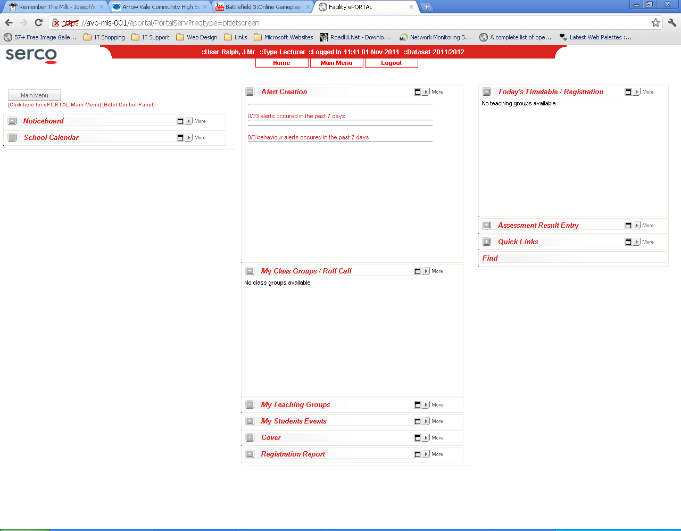

**Useful Tip:**

The box you are looking for should look similar to the one shown in the image to the left. This box could be hidden so if you find the Alert Creation bar and click the **+** icon it will expand it.

To create the alert you will want to click the ‘more’ button in the top right of the box. This will take you to a new page which will look like the below image.

The blank dropdown box lets you select the student. This box is ordered according to the letters chosen from the box before it.

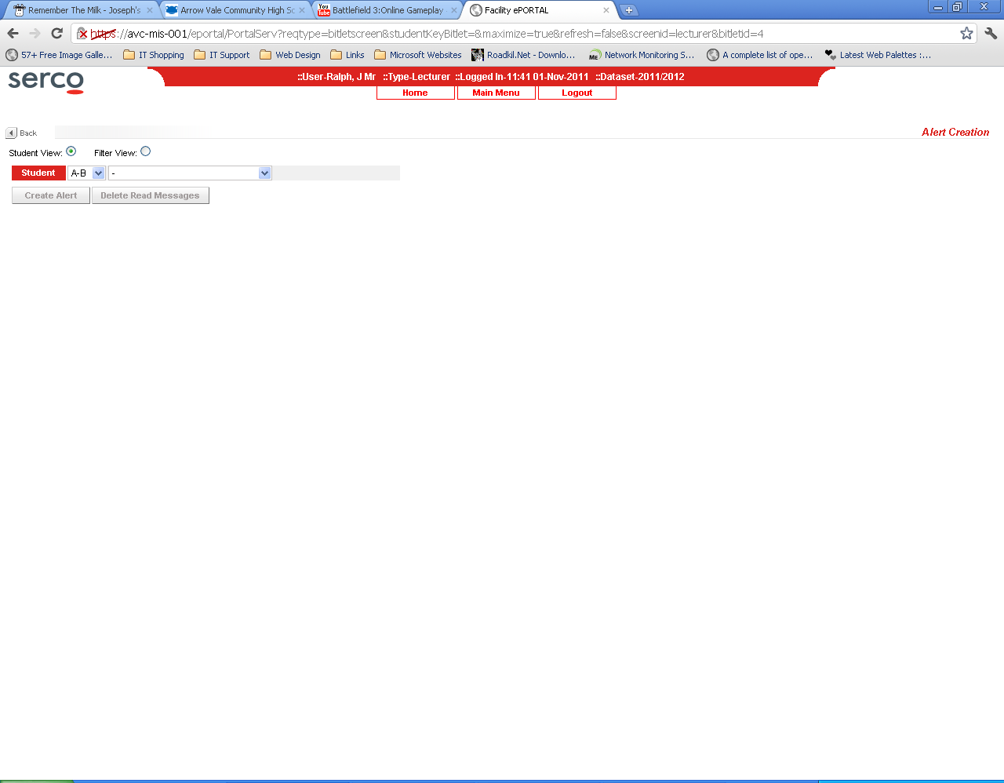

This section lets you search for the student to create an alert for.

The create alert button will take you to the page where you decide what message you want in the alert.

The letter dropdown list lets you chose the first letter of a student’s surname.

Once you have clicked the create alert button you will be given with the following screen.

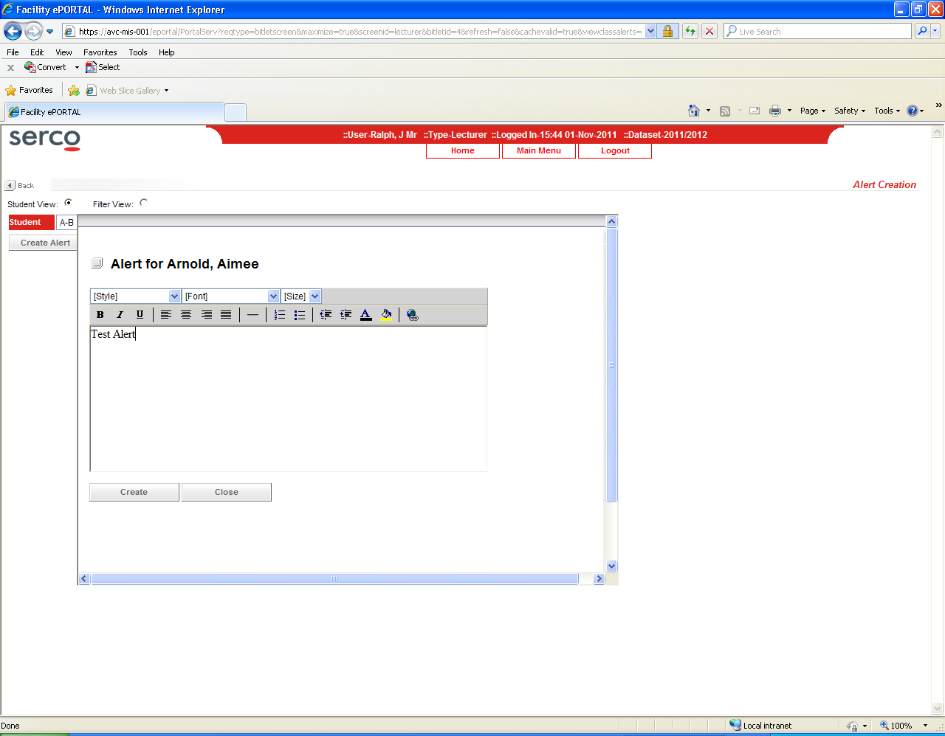

In this screen you can type in what you want the alert to say. Once this is done you can click the create button to create the alert or the cancel button to cancel it.

Once created, you will be able to view the alert on the register, which will be shown in the next step.

**View Register Alerts**

You can view the alert you have created in the register section of ePortal. This is shown below.

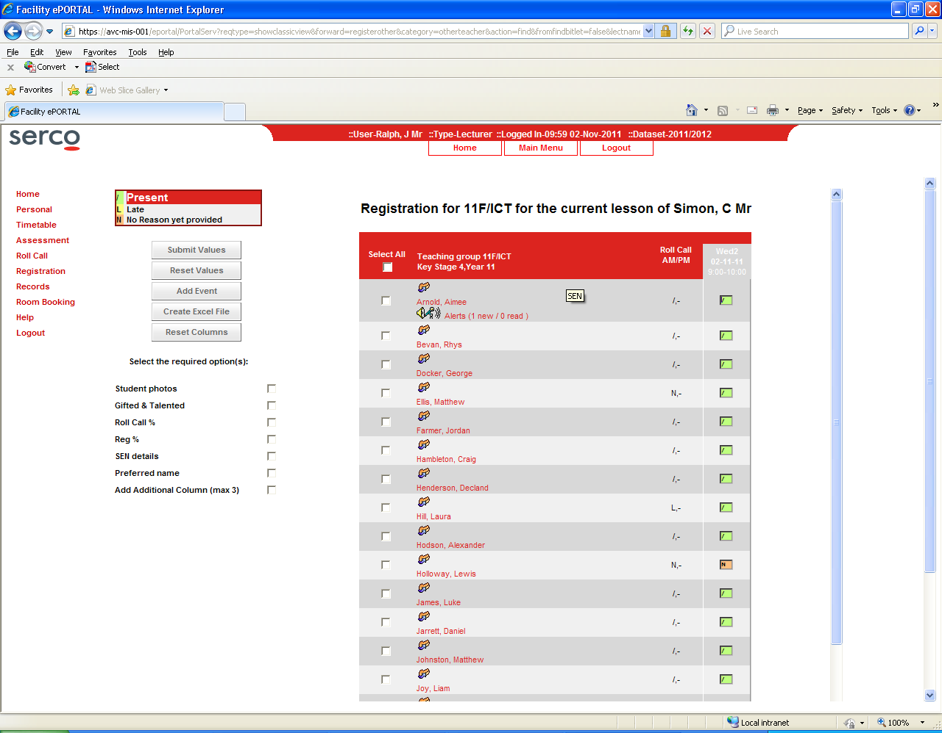

The alert will show up on the register under the students name. This alert can then be viewed by clicking on the alert, which will display a popup. Like below.

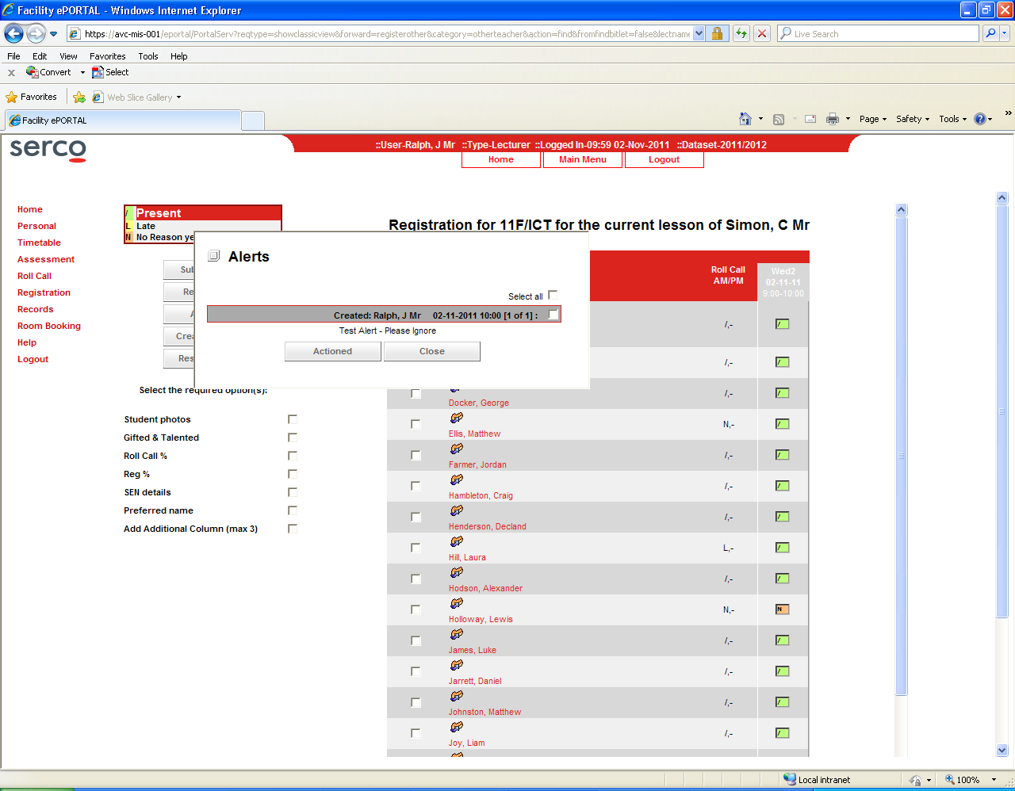

**Useful Tip:**

Once viewed, you can close the popup or you can ‘action’ the alert. Clicking the actioned button means you have taken the required action towards the alert.

**Deleting an Alert**

If you need to delete an alert for any reason (eg. If the alert was to the wrong student) you can do so by following the below steps.

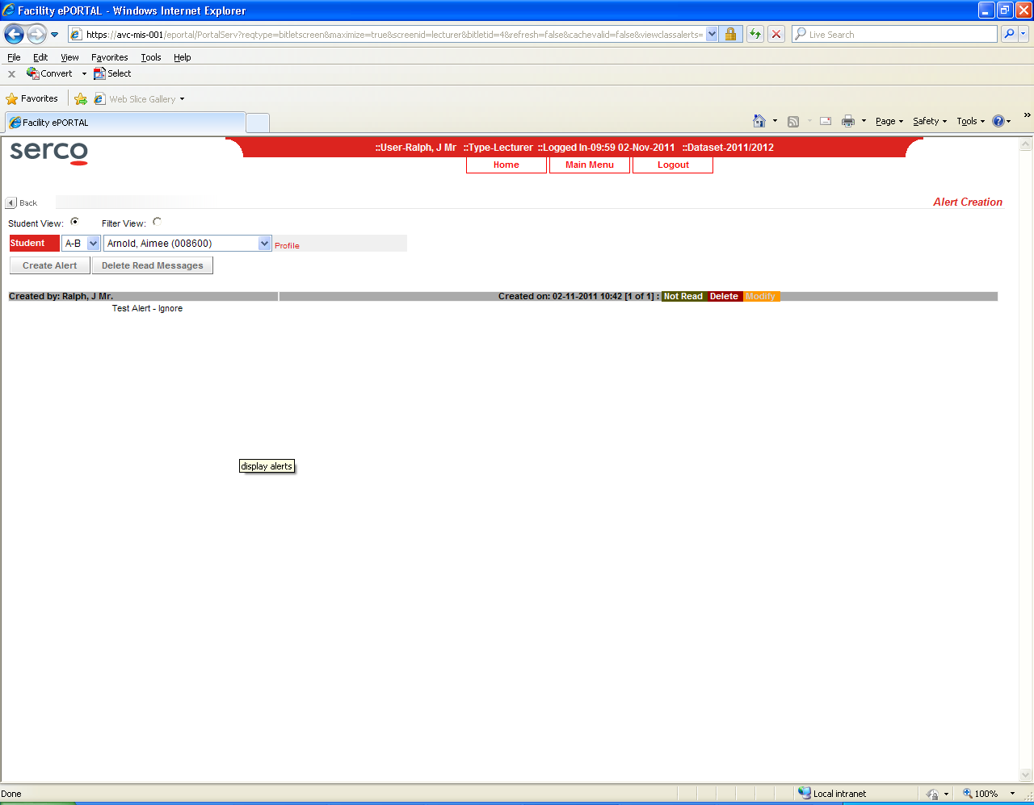If you go to the Alert Creation page from the home page, as shown above you will be able to select the student you created the alert for and delete the alert.

**Useful Tip:**

You can only delete an alert if it has not been read. Once an alert has been read, you will also be able to action the alert from this menu.